# Papa Ki Kamai

Rome, Romans and Countrymen, lend me your ears for I’m going to lead you to the path of flowing your ***mehnat ki kamai*** or ***mummy se mangi vi kamai,*** even if you aren’t blessed by a girlfriend. Most of us are seem to be more attracted by Pizzas and are always ready to enjoy one of the greatest pleasure of our life.

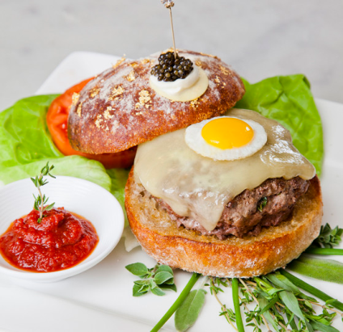**Nino’s Bellissima, New York city – $1000**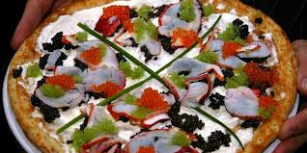

So the Chapter begins with Nino’s Bellissima Pizza, in New York, which seems to think there are many food lovers who would fork out $1,000 for a slice of heaven. Wait! Those who have tried the $1,000 pie at Nino’s Bellissima Pizza say it’s very tasty, but that it doesn’t taste like a pizza at all. So I wouldn’t exactly refer to it as futile but definitely, fruitless as compared to what you paid for it.

#### Le Burger Extravagant- $293

You don’t like pizza? No, problem, there are hamburgers too. This is the first of three expensive food entries courtesy of the infamous Serendipity 3 in New York. Le Burger Extravagant is made of a Wagyu beef patty that’s infused with 10 herbs and white truffle butter, subtly seasoned with Alderwood smoked Pacific sea salt. It’s topped with black truffles, a fried quail egg and cheese. But that is not enough, oooh no! Holding this extravagant burger together is a gold encrusted, diamond studded toothpick. The burger is served with a blini, crème fraiche and Kaluga golden caviar. So, your vote, fruitless or futile?

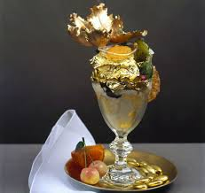The **Golden Opulence Sundae - US $1000**

**Moving on, I present you,** a [sundae](http://en.wikipedia.org/wiki/Sundae) that is served by special order at the [New York City](http://en.wikipedia.org/wiki/New_York_City) restaurant [Serendipity 3](http://en.wikipedia.org/wiki/Serendipity_3). In 2007 it was listed in [*Guinness World Records*](http://en.wikipedia.org/wiki/Guinness_World_Records) as the most expensive sundae in the world at a price of US$1,000.[[1]](http://en.wikipedia.org/wiki/Golden_Opulence_Sundae#cite_note-1) The restaurant has stated that they sell approximately one per month. It was created to celebrate the eatery's 50th - ["golden"](http://en.wikipedia.org/wiki/Golden_anniversary) - anniversary in 2005.[[2]](http://en.wikipedia.org/wiki/Golden_Opulence_Sundae#cite_note-daily-2) Owner Stephen Bruce states that a notice 48 hours in advance is needed when requesting the Sundae, since ingredients must be flown in from different parts of the world.

Anyway, there are foodies out there roaming in search of their pleasures and they do seek for best of these dishes. So there you go foodies, for now, ***das ist alles.***Now presenting you the most counterproductive things ever.

**I Am Rich – US $1000**

An [iOS](http://en.wikipedia.org/wiki/IOS) application which was formerly distributed using the [App Store](http://en.wikipedia.org/wiki/App_Store_%28iOS%29), and developed by Armin Heinrich. When launched, the screen only contains a glowing red gem, and an icon that when pressed, displays the a [mantra](http://en.wikipedia.org/wiki/Mantra) in large text. The application is described as "a work of art with no hidden function at all", with its only purpose being to show other people that they were able to afford it, making it a [Veblen good](http://en.wikipedia.org/wiki/Veblen_good). Okay ! Now I think is the appropriate time for your slangs to scuttle through your lips.

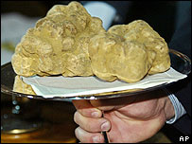**Italian Truffle – US $112,000**

A truffle weighing 1.2kg (2.6lb) has sold for 95,000 euros ($112,000; £64,000) at an international charity auction in Italy. An anonymous buyer - reportedly from Hong Kong - purchased the white truffle via satellite link-up. A white truffle is a very rare type of mushroom that grows underground.

**Spin Jeans – US $27,000**

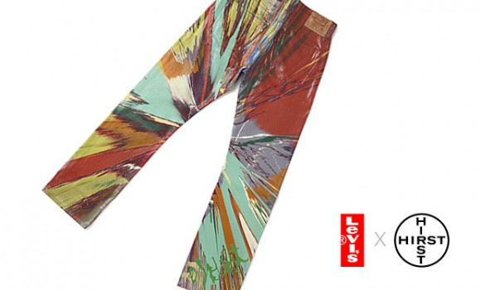

Hipsters never let a little global financial tsunami interefere with fashion! Here’s the “Spin Jean” by Daniel Hirst, in collaboration with Levi’s. Bold and brash, he teams up with Levi’s on the release of a new denim style. Hardly wearable, the jeans seen here should be considered much more a re-appropriated piece of art than fashion. The Spin Jeans comprise of only 8 instances worldwide with a suggested retail price of approximately $27,000 USD.

Loved my collection of counter productiveness? Well, now I shall stretch the time constant for you to tight you gauntlets & tear the pages apart. But just for the sake of the integrity of my friendship I suggest you once go through the hard work of my colleagues and give them a try. (I don’t think I you’d now trust me when I‘d say they write well.) Good Bye, Countrymen. Bonjour!